Cryptography Challenges
Crypto Low :
MD hash
In the folder, found a Flag-1.zip and md5 file which contains md5 hash for the “monkey1” and I got this from “really bad passwords unsalted hashes”. I converted the zip file to rar file and opened it using WinRAR archive where a password protected Flag-1.txt exists. Using the password “monkey1”, I got the text “{CR4CK!NG-MD5-H4$H}”.
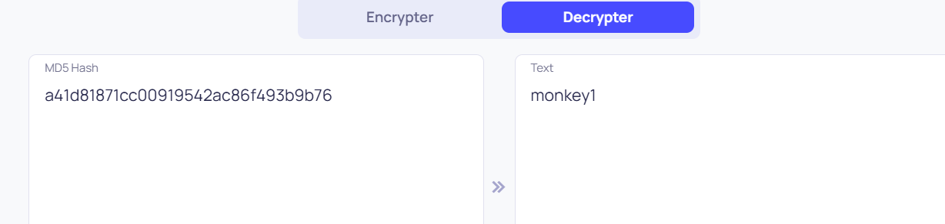
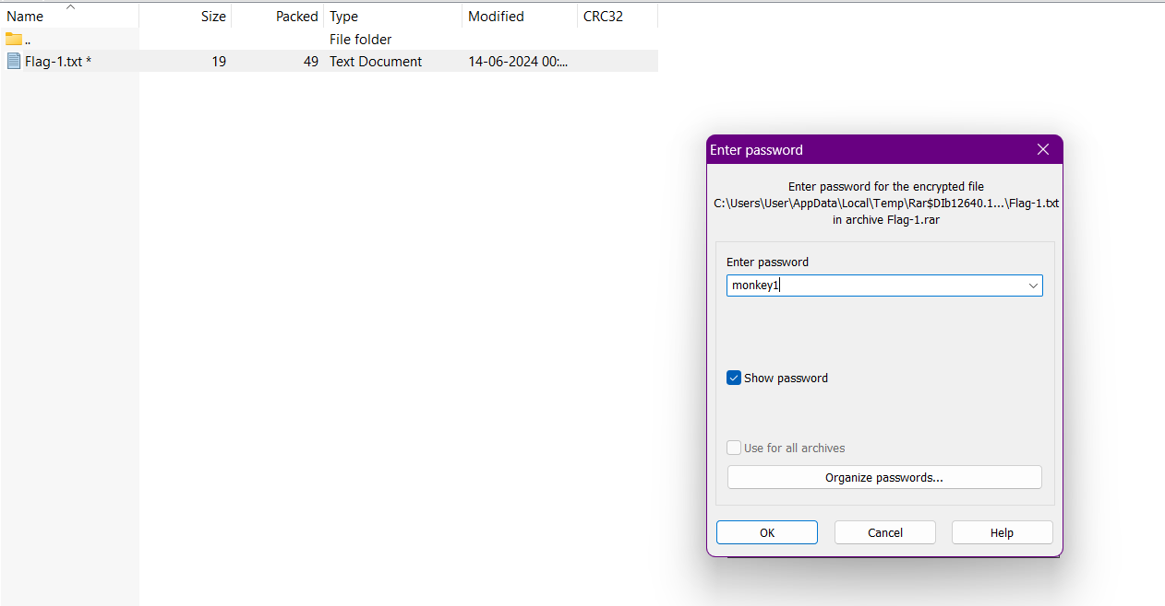

SHA hash
In this folder, I’ve found one Flag-2.txt and SHA1 file. The Flag-2.txt is encoded using BCtextencoder so I used BCtextdecoder and the password “Password123” I’ve got from the hash present in SHA1 file to get this “{P4SS-CR4CK!NG-SHA-H4$H}”.
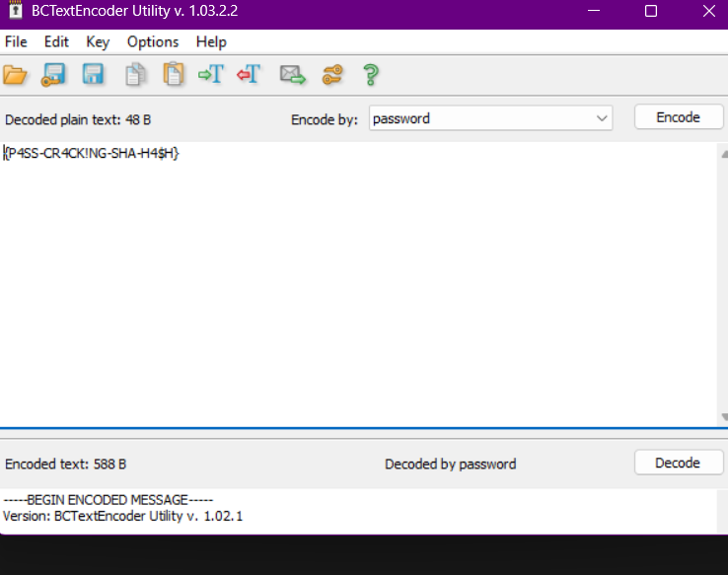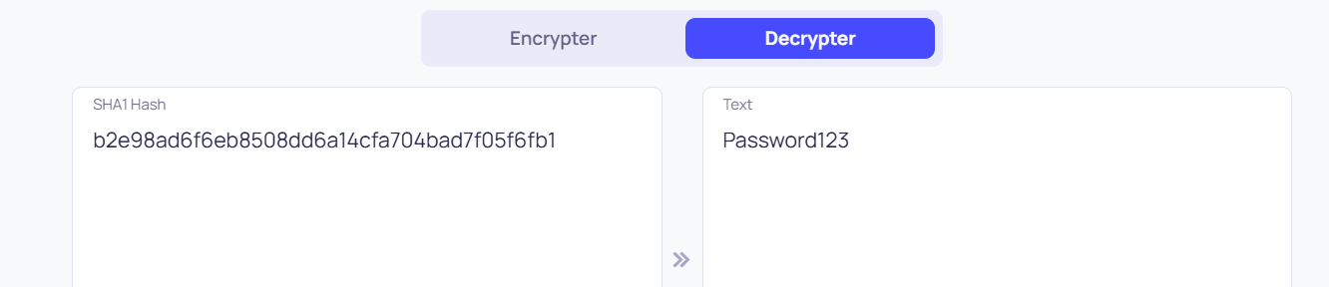
Crypto Medium :
Challenge 3
In the Challenge - 3.docx file, there is a link https://www.mediafire.com/file/e7fy9cn5yfaxtwb/ch.crypto/file from which I downloaded the file ch.crypto. So I used the encrypto tool and from the hint: Remaining Name, I’ve got the password “allenge - 3”. Retreived the file ch.txt which contained the binary data “01001100 01010101 01000100 01010001 01010000 01000011 00100000 00100000 01000011 01010011 00110010 01000011 00111000 00100101 01000101 01010111 00110010 01000011 01010101 01001010 01000101 00110110 00110001” which is converted to “LUDQPC CS2C8%EW2CUJE61”.



